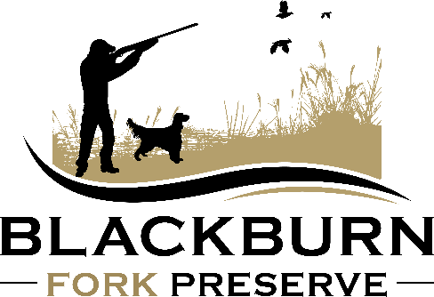
Blackburn Fork Preserve
2471 Airport Road, Altoona, AL 35952
WAIVER AND RELEASE AGREEMENT
Please read carefully before signing.
This is a release of liability and waiver of certain legal rights.
In consideration for my being permitted to enter for any purpose the hunting facilities (the “Facilities”) operated by DOLAN & ASSOCIATES, LLC known as BLACKBURN FORK PRESERVE (the “Preserve”), I agree to the following Waiver and Release:
I acknowledge that hunting and/or target shooting has inherent risks, hazards, and dangers for anyone that cannot be eliminated, particularly in a wilderness environment. I UNDERSTANT THAT THESE RISKS, HAZARDS, AND DANGERS INCLUDE WITHOUT LIMITATION:
- The risk of handling firearms and being near others that have firearms in their possession;
- The risk of ear damage from noise;
- The risk of injury from ammunition, clay targets and shot from other guns;
- Walking in rugged country, including encounters with wildlife, animals and insects;
- Inclement weather conditions.
I understand the risks, hazards, and dangers of the use of firearms and have had the opportunity to discuss them with the Preserve. I understand that these activities may require good physical conditioning and a degree of skill and knowledge. I believe I have that good physical conditioning and the degree of skill and knowledge necessary for me to engage in these activities safely. I understand that I have responsibilities. My participation in this activity is purely voluntary. No one is forcing me to participate and I elect to participate in spite of the risks. I AM VOLUNTARILY USING THE SERVICES OF BLACKBURN FORK PRESERVE, WITH FULL KNOWLEDGE OF THE INHERENT RISKS, HAZARDS, AND DANGERS INVOLVED AND HEREBY ASSUME AND ACCEPT FULL RESPONSIBILITY FOR ALL RISKS OF INJURY, PARALYSIS, DEATH AND/OR PROPERTY DAMAGE (includes but not limited to the Preserve dogs, vehicles, property and furnishings).
Lastly, I, for myself, my heirs, successors, executors, and subrogates, hereby KNOWINGLY AND INTENTIONALLY WAIVE AND RELEASE, INDEMNIFY AND HOLD HARMLESS, BLACKBURN FORK PRESERVE, their directors, officers, agents, employees, and volunteers from and against any and all claims, actions, causes of action, liabilities, suits, expenses, (including reasonable attorneys’ fees) which are related to, arise out of, or are in any way connected with my participation in this activity including, but not limited to, NEGLIGENCE of any kind or nature, whether foreseen or unforeseen, arising directly or indirectly out of any damage, loss, injury, paralysis, or death to me or my property as a result of my engaging in these activities of the use of these services, animals or equipment, whether such damage, loss, injury, paralysis, or death results from negligence of Blackburn Fork Preserve, or from some other cause. I for myself, my heirs, my successors, executors, and subrogates, further agree not to sue Blackburn Fork Preserve as a result of any injury, paralysis, or death suffered in connection with my use and participation in the activities of Blackburn Fork Preserve.
I HAVE BEEN GIVEN A COPY OF BLACKBURN FORK PRESERVE’S SAFETY RULES FOR QUAIL HUNTERS; I HAVE READ AND AGREE TO ABIDE THE RULES AS PROVIDED.

I HEREBY AGREE THAT NO ORAL REPRESENTATIONS, STATEMENT OR INDUCEMENTS APART FROM THIS WRITTEN AGREEMENT HAVE BEEN MADE.
I HAVE CAREFULLY READ, CLEARLY UNDERSTAND, AND VOLUNTARILY SIGN THIS WAIVER AND RELEASE AGREEMENT.

_____________________ _____________________________________________________
Date Signature
________________________________________________________________
Print Name
________________________________________________________________
Mailing Address
________________________________________________________________
City State Zip
________________________________________________________________
e-Mail Phone Number

